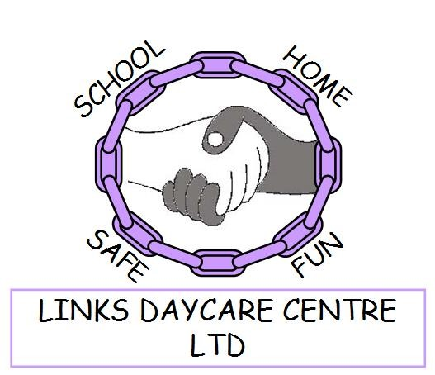
The Links Daycare Centre Ltd
Victoria Road
Hartshill
Nuneaton
Warwickshire
CV10 0LS
Tel: 02476 394782
Email: linkschildcare@gmail.com
Nursery Education Funding Policy
September 2025

At The Links Daycare Centre Ltd we offer the Government funding allocated from the Government using the following formulas.
- 2 year olds (2 Help 15 hours and Expanded Working Parent 30 hours funding)

- 3 & 4 year olds (Universal Funded 15 hours and Extended Working Parent Entitlement 15 hours combined)

Funded sessions are Monday – Friday (Term Time), between the hours of
9am -3pm – These can be used in the following ways:
9am | 12pm
12pm | 3pm
9am | 3pm

All eligibility criteria must be confirmed before we can allocate funded sessions.
Voluntary Consumable Charge at Links Daycare Centre
We charge £20.00 per term (Spring, Summer, Autumn term) to cover the cost of consumables to the setting e.g. snacks.
You will be given an invoice that carefully details your pattern of attendance and any charges for your child whilst at nursery.
Additional services are listed below with costings- These are discussed with parents, and individual paysheet are shared with families detailing their charges ensuring everyone is aware of the pay schedule.
Proof of payment can be issued if required.
If you do require further information regarding the above, please ask to speak to a member of the Links Management Team.
Nursery Price Structure - Effective September 2025
Age 2
Breakfast Club 7:45 – 9:00am  9:00am – 12:00 mid-day (AM) or  12:00 mid-day – 3:00pm (PM)  After 3pm – Wraparound – session one until 4:15pm, session 1 & 2 until 5:15pm, session 1,2 & 3 until 5:45pm-CLOSURE. | £9.00  £27.00 per session  (9-3 school day = £54)  1st session £9.00  2nd session £9.00 (£18)  3rd session £6.50 (£24.50)  (All 3 sessions till end £24.50)
Age 3/4
Breakfast Club 7:45 – 9:00am  9:00am – 12:00 mid-day (AM) or  12:00 mid-day – 3:00pm (PM)  After 3pm – Wraparound – session one until 4:15pm, session 1 & 2 until 5:15pm, session 1,2 & 3 until 5:45pm-CLOSURE. | £8.50  £25.50per session  (9–3 school day = £51)  1st session £8.50  2nd session £8.50 (£17.00)  3rd session £6.00 (£23)  (All 3 sessions till end £23)
To be reviewed for September 2026

